Are you looking for things to do at home

with your little ones?

Then why not try

….



Play!

Talk!

Read!



These are FREE 6 week

**virtual learning**

programme that contain

a variety of activities and experiences. You can select from one of

the available programmes;

**Baby Massage, Messy Play, Little Sparklers,**

**Sports/Physical, Junior Explorers**

Programme material can be accessed via Email and WhatsApp.

You

’

ll receive a goody bag for completing, so to register your

interest or ask for further information then please call

0121 588 5431

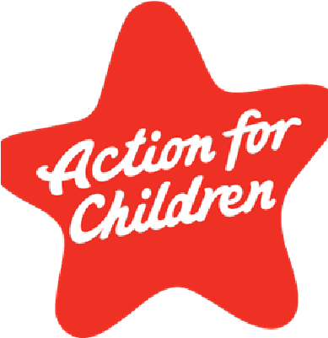

**We can create you a Digital Photo Collage to remember**

**your experiences!**

